Infrastructure-as-Code Deployment Documentation
🧾 Project Overview
This project provisions a secure AWS architecture using Terraform. It includes:
- Custom VPC with public and private subnets
- API EC2 instance in public subnet
- Worker EC2 instances in private subnet
- Security groups controlling SSH and application traffic
- RPC communication between API and workers using port 5000
Architecture:
User / Client
|
| HTTP (JSON request)
v
API Server (Public EC2)
|
| Internal call (RPC / private IP)
v
Worker Server (Private EC2)
|
| Process data
v
API Server
|
| JSON Response
v
User
Terraform Deployment:
Terraform plan:

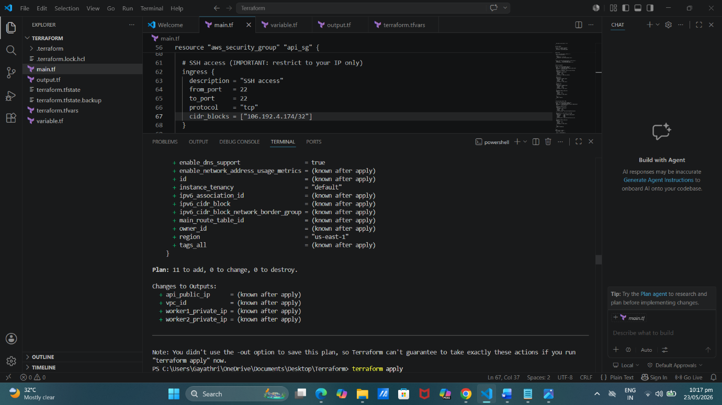

Terraform apply:

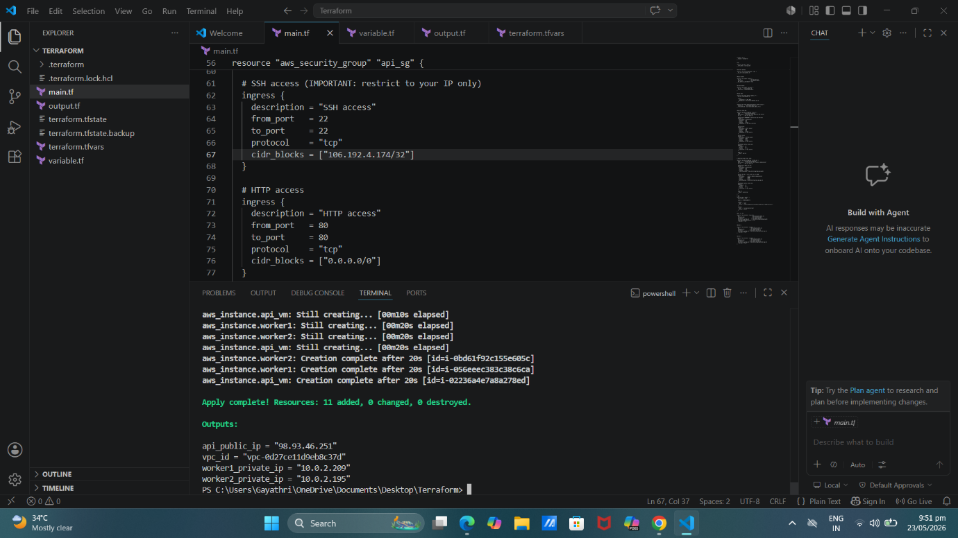

Infrastructure Components:
1. VPC
- CIDR: 10.0.0.0/16
- Provides isolated network environment

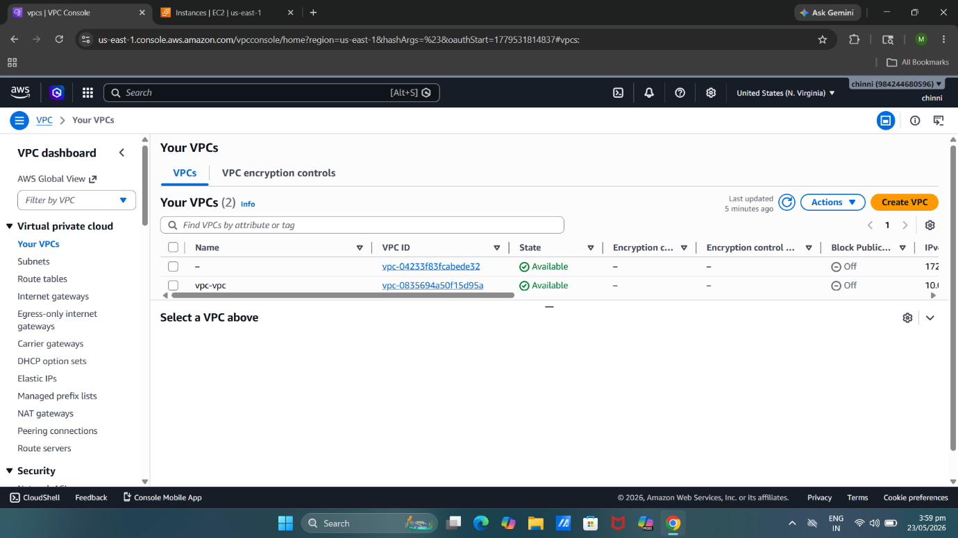

2. Subnets
- Public Subnet
  - Hosts API server
- Private Subnet
  - Hosts worker nodes
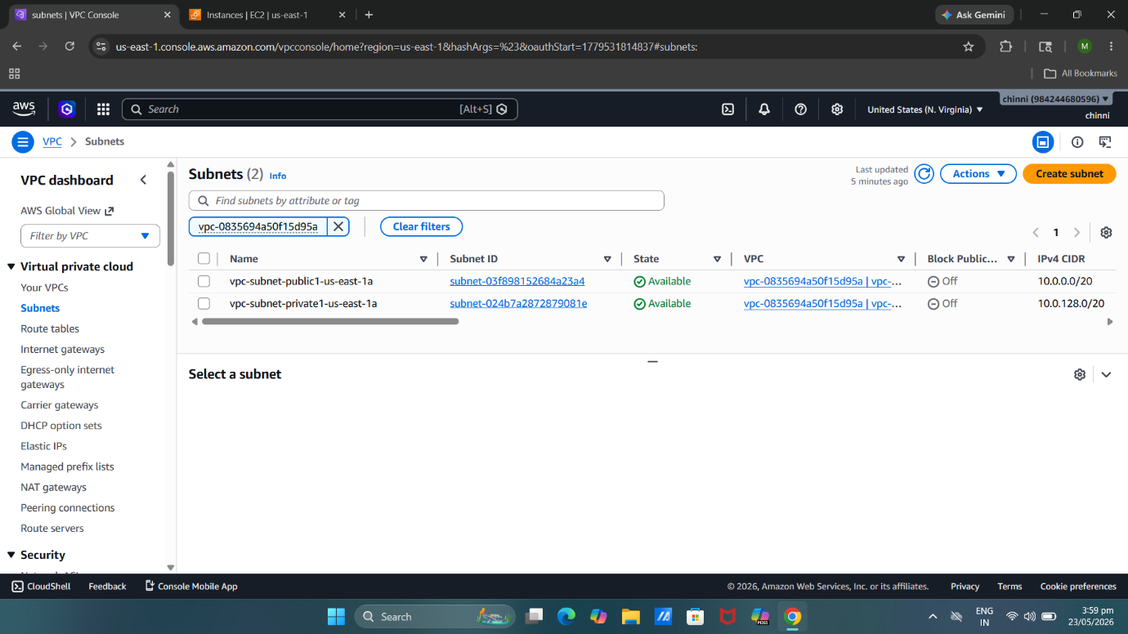

3. EC2 Instances
API Server
- Publicly accessible
- Handles incoming HTTP requests
Worker Nodes
- Located in private subnet
- Not directly accessible from internet
- Accept requests only from API security group

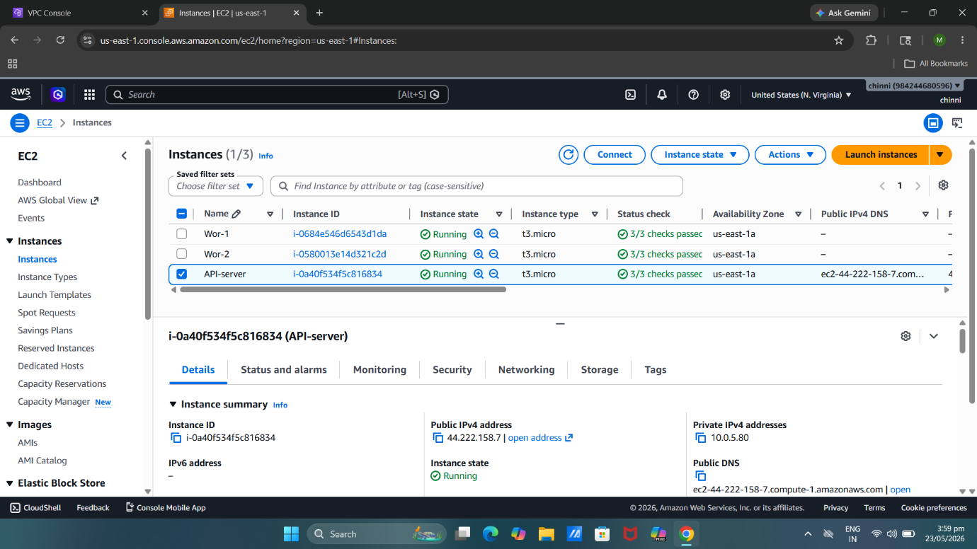

4. Security Groups
🔐 API Security Group
- SSH → Port 22 (restricted to your IP)
- HTTP → Port 80 (open to internet)
- HTTPS → Port 443 (open to internet)

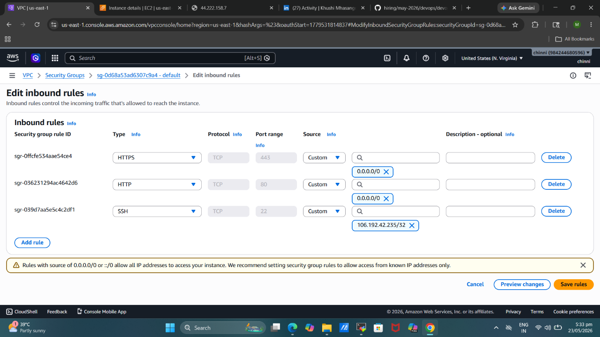

Worker Security Group
- SSH → Port 22 (restricted to your IP)
- Application → Port 5000 (only from API security group)

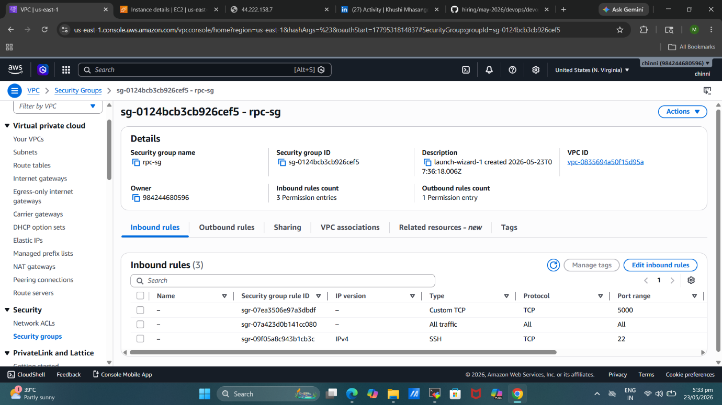

Worker Node Configuration
- Both worker nodes contain:
- Python installed
- RPC application running
- Port 5000 enabled internally
Installation commands:
sudo apt update
sudo apt install python3 python3-pip -y
pip3 install flask
Run worker application:
python3 worker.py
RPC Communication Flow
- Client sends request to API server
- API server forwards request to worker nodes
- Worker node processes request
- Worker returns response
- API server returns JSON response to client
API Test Command:
curl -X POST http://<API-PUBLIC-IP>:5000/predict \
-H "Content-Type: application/json" \
-d '{"data":[1,2,3,4]}'
Sample Response:
{
"prediction": 42
}

